You may find it useful to see a selection of question types relating to clauses and conjunctions, that your child might be expected to answer in the KS2 SATs tests.

Tick one box to show whether the underlined section of each sentence is a main clause or a subordinate clause.
2 marks
 | Main Clause | Subordinate Clause
As he was the tallest, Jake opened the window blinds.
The resplendent eagle soared across the sunset-stained sky before diving towards the earth below.
Maggie arrived at school on time despite sleeping through her alarm.
The leopard, who had slept all day in the shade, roused itself and prepared to hunt.
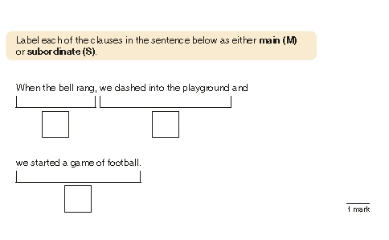

KS2 Parents’ Workshop, Monday 09/01/23
Main and Subordinate Clauses.
What is a main clause?
- The main part of the sentence
- It gives you the most important information
- It can be identified by: working out which part of the sentence could make sense on its own (be a stand alone sentence). This is also known as an independent clause.
- Two main clauses can be joined together by a co-ordinating conjunction.
What is a subordinate clause?
- A subordinate clause is dependent on the main clause.
- They can come at the beginning, middle or the end of a sentence
- It can be identified by: looking for the part of the sentence that wouldn’t make sense on its own (it couldn’t be a stand alone sentence).
- It begins with a subordinating conjunction.

- begins with a subordinating conjunction.

